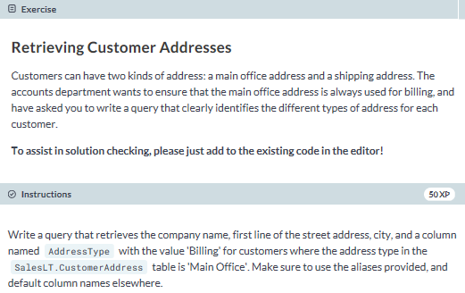

**-- select the CompanyName, AddressLine1 columns**

**-- alias as per the instructions**

**SELECT c.CompanyName, a.AddressLine1, a.City, 'Billing' AS AddressType**

**FROM SalesLT.Customer AS c**

**JOIN SalesLT.CustomerAddress AS ca**

**-- join based on CustomerID**

**ON c.CustomerID = ca.CustomerID**

**-- join another table**

**JOIN SalesLT.Address AS a**

**-- join based on AddressID**

**ON a.AddressID = ca.AddressID**

**-- filter for where the correct AddressType**

**WHERE ca.AddressType = 'Main Office';**

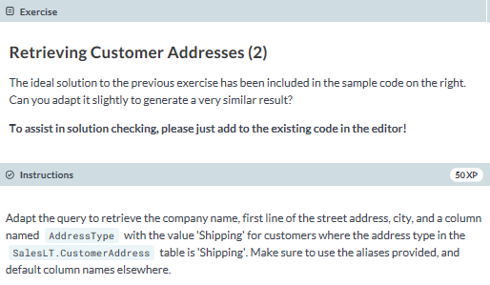

**-- edit this**

**SELECT c.CompanyName, a.AddressLine1, a.City, 'Shipping' AS AddressType**

**FROM SalesLT.Customer AS c**

**JOIN SalesLT.CustomerAddress AS ca**

**ON c.CustomerID = ca.CustomerID**

**JOIN SalesLT.Address AS a**

**ON ca.AddressID = a.AddressID**

**-- edit this**

**WHERE ca.AddressType = 'Shipping';**

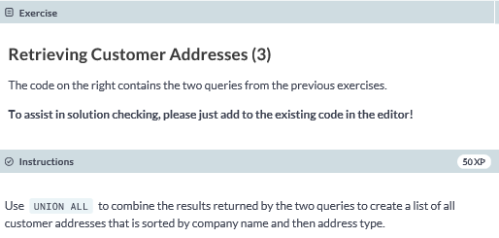

**SELECT c.CompanyName, a.AddressLine1, a.City, 'Billing' AS AddressType**

**FROM SalesLT.Customer AS c**

**JOIN SalesLT.CustomerAddress AS ca**

**ON c.CustomerID = ca.CustomerID**

**JOIN SalesLT.Address AS a**

**ON ca.AddressID = a.AddressID**

**WHERE ca.AddressType = 'Main Office'**

**-- edit this as per the instructions**

**UNION ALL**

**SELECT c.CompanyName, a.AddressLine1, a.City, 'Shipping' AS AddressType**

**FROM SalesLT.Customer AS c**

**JOIN SalesLT.CustomerAddress AS ca**

**ON c.CustomerID = ca.CustomerID**

**JOIN SalesLT.Address AS a**

**ON ca.AddressID = a.AddressID**

**WHERE ca.AddressType = 'Shipping'**

**ORDER BY c.CompanyName, AddressType;**

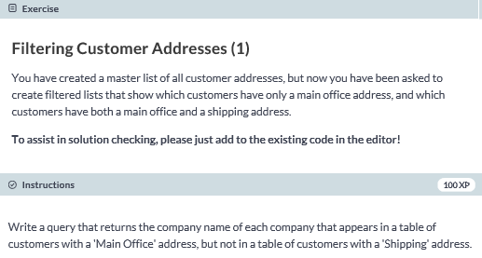

**SELECT c.CompanyName**

**FROM SalesLT.Customer AS c**

**-- join the CustomerAddress table**

**JOIN SalesLT.CustomerAddress AS ca**

**ON c.CustomerID = ca.CustomerID**

**JOIN SalesLT.Address AS a**

**-- join based on AddressID**

**ON a.AddressID = ca.AddressID**

**WHERE ca.AddressType = 'Main Office'**

**EXCEPT**

**SELECT c.CompanyName**

**FROM SalesLT.Customer AS c**

**-- use the appropriate join to join the CustomerAddress table**

**JOIN SalesLT.CustomerAddress AS ca**

**-- join based on CustomerID**

**ON c.CustomerID = ca.CustomerID**

**-- use the appropriate join to join the Address table**

**JOIN SalesLT.Address AS a**

**ON ca.AddressID = a.AddressID**

**-- filter for the appropriate AddressType**

**WHERE ca.AddressType = 'Shipping'**

**ORDER BY c.CompanyName;**

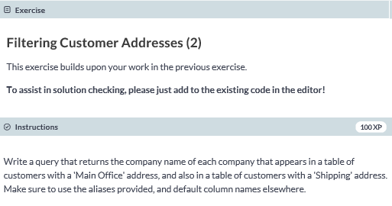

**-- select the CompanyName column**

**SELECT c.CompanyName**

**-- from the appropriate table**

**FROM SalesLT.Customer AS c**

**-- use the appropriate join with the appropriate table**

**JOIN SalesLT.CustomerAddress AS ca**

**-- join based on CustomerID**

**ON c.CustomerID = ca.CustomerID**

**-- use the appropriate join with the appropriate table**

**JOIN SalesLT.Address AS a**

**-- join based on AddressID**

**ON a.AddressID = ca.AddressID**

**-- filter based on AddressType**

**WHERE ca.AddressType = 'Main Office'**

**INTERSECT**

**-- select the CompanyName column**

**SELECT c.CompanyName**

**FROM SalesLT.Customer AS c**

**-- use the appropriate join with the appropriate table**

**JOIN SalesLT.CustomerAddress AS ca**

**ON c.CustomerID = ca.CustomerID**

**JOIN SalesLT.Address AS a**

**-- join based on AddressID**

**ON a.AddressID = ca.AddressID**

**-- filter based on AddressType**

**WHERE ca.AddressType = 'Shipping'**

**ORDER BY c.CompanyName;**